


ARGE Neue Medien, October 2021

Press release

ARGE cooperates with IdroLAB

The ARGE is committed to the internationalization of the product data of its members. With building-masterdata.com ARGE is operating a powerful platform for distributing article master data in many European countries. The international data quality guideline Building Masterdata Guideline defines necessary standards for the compilation of that data.

Moreover, the ARGE aims for a high degree of digital networking with existing international offers and relies on country-specific cooperation with regard to international product data.
Recently, an agreement was signed with the Italian IdroLAB. The company's CEO Massimo Minguzzi already gave an expert speech on the importance of product data content at the ARGE general meeting in May. IdroLAB is the leading provider of IT services for increasing automatic management processes of information and product resources in Italy. It provides online services for the building technology and installation sector. This includes e. g. the innovative information platform DOMUSPARTES.

With this service on the one hand and building-masterdata.com on the other, both partners bring their platforms together as an interface for joint activities and thus cooperate in the provision of master data for Italy. IdroLAB converts the BMDG data into the standard ANGAISA formats. The data is distributed directly to Italian dealers and distributors via the IdroLAB data portals.

Wolfgang Richter, Managing Director of the ARGE, describes the importance of the collaboration: “The definition of standards and the distribution of data, at the European level, are complex processes. Individual country interests, local formats as well as interfaces to established online platforms are playing a considerable role for us with regard to the international customers. We are looking forward to the synergies which will result from working together with IdroLAB.“

Massimo Minguzzi emphasizes the importance of high-quality product data: “In the digital world, information is the product. Our customers should have more time to sell their products than to invest time in searching for product data and electronic data processes”. The cooperation on the basis of the BMDG standard is an important part of this for him.

All ARGE activities are continuously supported by its members. Rudolf Kaiser, Director of B2B Process Management is spokesman of the ARGE expert commission and member of an international working group. He accompanies the work on international collaborations. Rudolf Kaiser is also very satisfied with the latest “digital step” to Italy: “On the basis of this cooperation we now have the opportunity to provide our Italian customers faster and considerably better with high-quality master data. And that efficient, comfortable and always up to date. We are using this collaboration agreement in order to meet the increasing market demand for ETIM classification data and logistical information. The international standard Building Masterdata Guideline enables us to deliver the complete data content and attributes which are requested by our customers. This standardized way of data provision can also be used in the same way by other suppliers. In this way then data management efforts in retail can be reduced significantly.“

More Information
www.domuspartes.it
www.idrolab.net
www.building-masterdata.com
www.arge.de

Contact
ARGE Neue Medien
Wolfgang Richter: wrichter@arge.de; Fon: +49 5251 87288-29

492 words

Picture
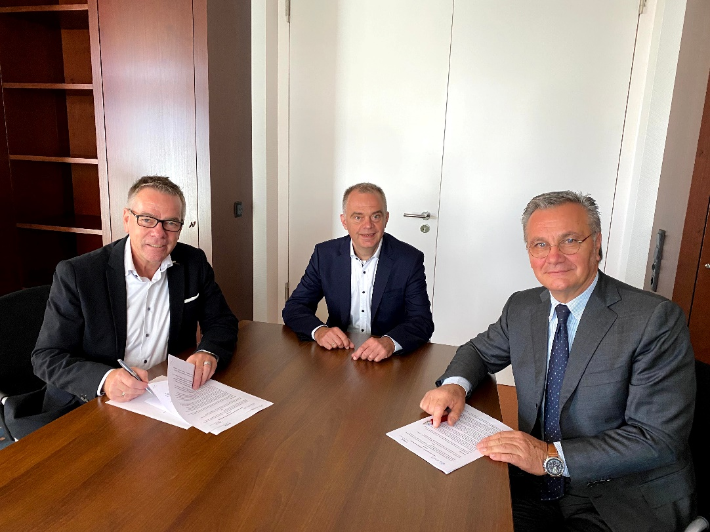

Wolfgang Richter and Massimo Minguzzi after signing the cooperation agreement.
Rudolf Kaiser (Viega) accompanies the activities as an expert.

The signing took place in Paderborn on September 30th, 2021. All persons involved have followed the currently valid Corona protection and 3G rules.

Picture: ARGE Neue Medien, Paderborn

